Fields are required unless marked optional. See repo for basic WIP [content template fields](https://github.com/department-of-veterans-affairs/va.gov-team/blob/master/products/content/tier-2-content-IA-and-design/learning-center-mvp/template-requirements.md#content-fields-on-all-learning-center-pages).

[Mural board WIP wireframes](https://app.mural.co/t/departmentofveteransaffairs9999/m/departmentofveteransaffairs9999/1588167553516/2773c854e8ff3a725a5e3ee03272b78e8519f78b)

**Content template fields – Step-by-step: How to change your VA address online**

|  |  |
| --- | --- |
| **H1 (page title)** | **How to change your VA address online** |
| [**Topic tag**](https://github.com/department-of-veterans-affairs/va.gov-team/blob/master/products/content/tier-2-content-IA-and-design/learning-center-mvp/template-requirements.md#topic-tags) | *VA account and profile* |
| [**Audience tag**](https://github.com/department-of-veterans-affairs/va.gov-team/blob/master/products/content/tier-2-content-IA-and-design/learning-center-mvp/template-requirements.md#audience-tags)Up to 3. Cannot mix beneficiary and non-beneficiary. | *Veterans* |
| **CTA button 1** | *URL: {open sign in modal}*  *Button text: Sign in to change your address* |
| **CTA button 2 (optional)** | *URL:*  *Button:* |
| **TOC links (optional)** | *NO* |
| **Back to top links (optional)** | *NO* |

**Intro block**: *Rich text formattable WYSIWYG – 1,000 characters max including spaces.*

When you change your address and other contact information online in your VA.gov profile, it will update for all of the following VA benefits and services:

* VA health care (including prescriptions, appointment reminders, lab and test results, and communications from your VA medical center)
* Disability compensation
* Pension benefits
* Claims and appeals
* Veteran Readiness and Employment (VR&E), formerly called vocational rehabilitation and employment services

**{insert in-body info alert}** If you have other VA benefits or services that are not listed above—such as education, home loan, CHAMPVA, and others—you’ll need to contact the specific program to update your address.

[**Body content - See content type template specs**](https://github.com/department-of-veterans-affairs/va.gov-team/blob/master/products/content/tier-2-content-IA-and-design/learning-center-mvp/template-requirements.md#specific-lc-content-template-types)   
*(Step-by-step template)*

1. [**Sign in to VA.gov**](https://www.va.gov/change-address)  
   You can sign in with your DS Logon, My HealtheVet, or ID.me account. If you don't have an account, we’ll prompt you to create one.  
     
   [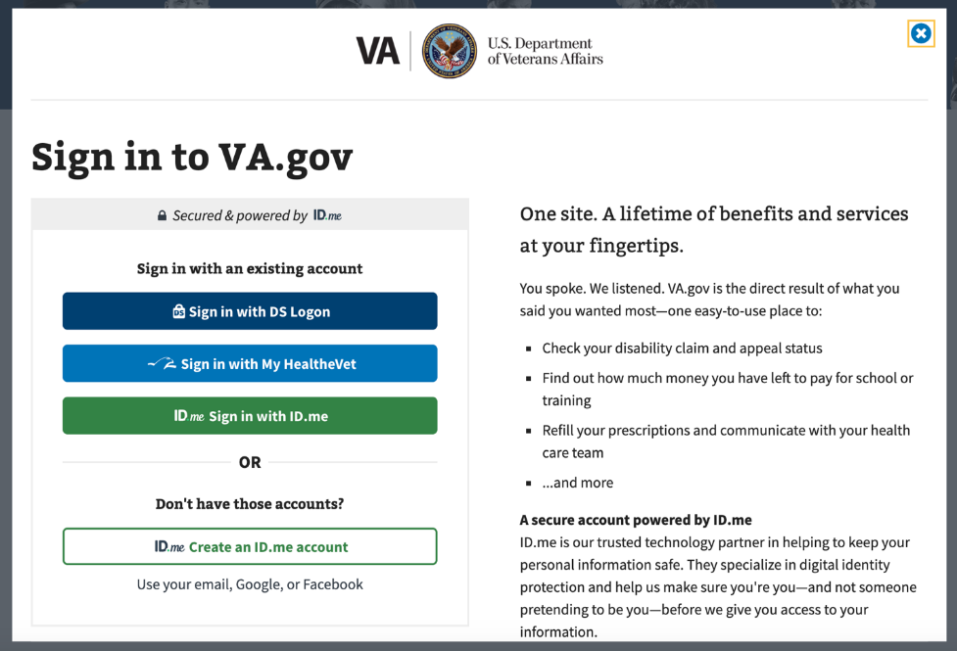]
2. **Verify your identity**   
   Choose how you want to receive the authentication code. You can choose a text message or a phone call. This step helps keep your information safe and prevent fraud and identity theft.  
     
     
   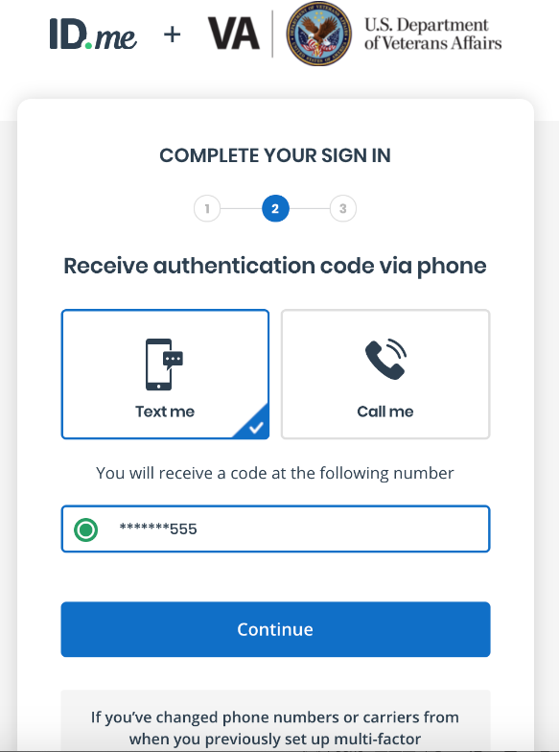
3. Enter the authentication code you received.

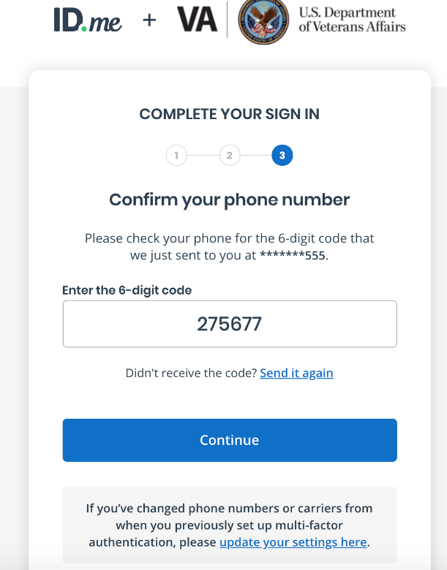

1. [**Go to your VA.gov profile**](https://www.va.gov/profile/)  
   Once you're signed in, you can find your profile by clicking on the icon with your name in the top right corner of any VA.gov page. Select **Profile** from the dropdown menu.   
     
   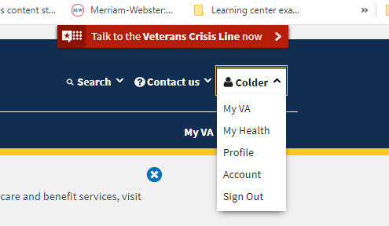
2. **Edit your address**  
   Click **Edit** next to the address you'd like to change. You can also add or edit your phone number and email address on this page.  
     
   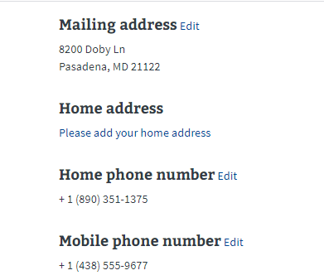
3. Fill out the form and click **Update** to save your changes.   
     
   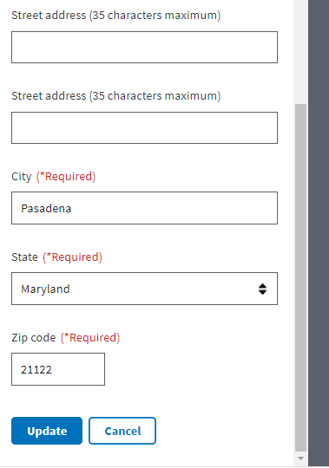

|  |  |
| --- | --- |
| **R**epeat **CTA buttons (optional)** | *YES* |
| **Need more help?** | * [**Call VA311 for help:** 844-698-2311](tel:1-844-698-2311) * **Chat with us:** VA chatbot |
| **Was this page helpful?** | *[Default content block. Not editable.]* |
| **Related information 1 (One default hub link required.)** | *[Default hub link+teaser text from homepage. Not editable.]*  VA account and profile information <link to LC list >  Find articles about signing in, creating a user account, how to manage your VA.gov account profile, and more. |
| **Related information 2 (optional)** | * [Change your VA direct deposit and contact information >](https://www.va.gov/change-direct-deposit)   [Change your direct deposit and contact information for certain VA benefits.](https://www.va.gov/change-direct-deposit) |
| **Related information 3 (optional)** | Change your address for other VA benefits > |